**REST - Get country based on country code**

**Step_1: Created based on this information:**

**Controller**: com.cognizant.spring-learn.controller.CountryController  
**Method Annotation:** @GetMapping("/countries/{code}")  
**Method Name**: getCountry(String code)  
**Method Implemetation**: Invoke countryService.getCountry(code)   
**Service Method:**com.cognizant.spring-learn.service.CountryService.getCountry(String code)

**Step-2: CountryService**

**package** com.cognizant.spring_learn.service;

**import** com.cognizant.spring_learn.Country;

**import** org.springframework.context.ApplicationContext;

**import** org.springframework.context.support.ClassPathXmlApplicationContext;

**import** org.springframework.stereotype.Service;

**import** java.util.List;

@Service

**public** **class** CountryService {

**public** Country getCountry(String code) {

ApplicationContext context = **new** ClassPathXmlApplicationContext("country.xml");

List<Country> countryList = context.getBean("countryList", List.**class**);

**return** countryList.stream()

.filter(c -> c.getCode().equalsIgnoreCase(code))

.findFirst()

.orElse(**null**);

}

}

**Step-3:**

@GetMapping("/countries/{code}")

**public** Country getCountry(@PathVariable String code) {

***LOGGER***.info("START: getCountry({})", code);

Country country = countryService.getCountry(code);

***LOGGER***.info("END: getCountry()");

**return** country;

}

**Output:**

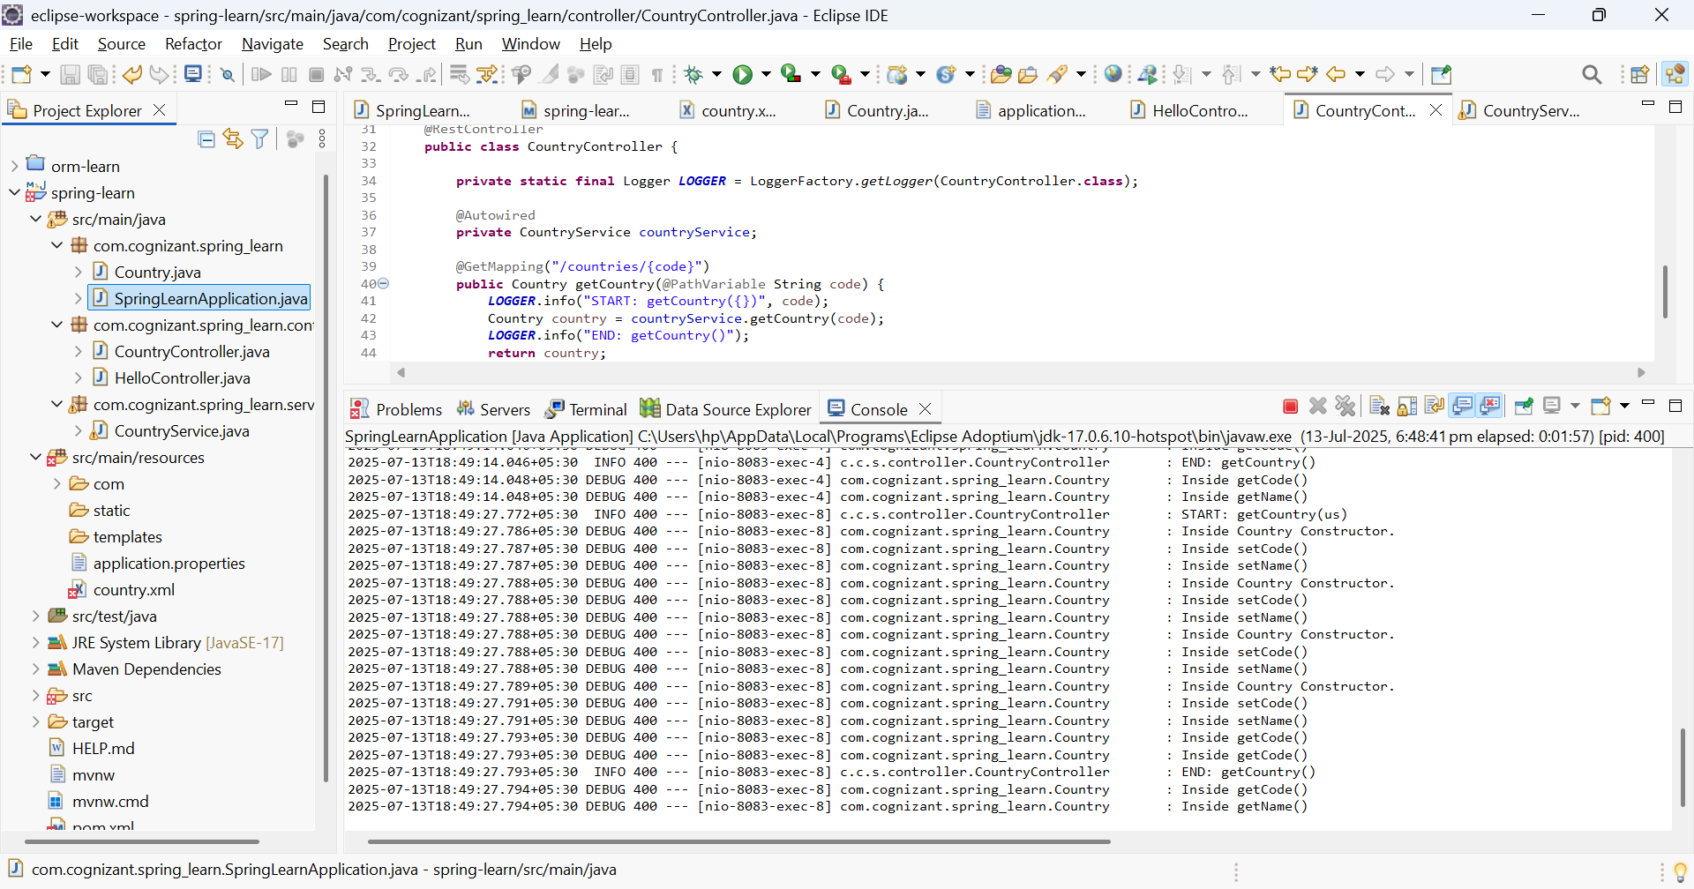

**PostMan**

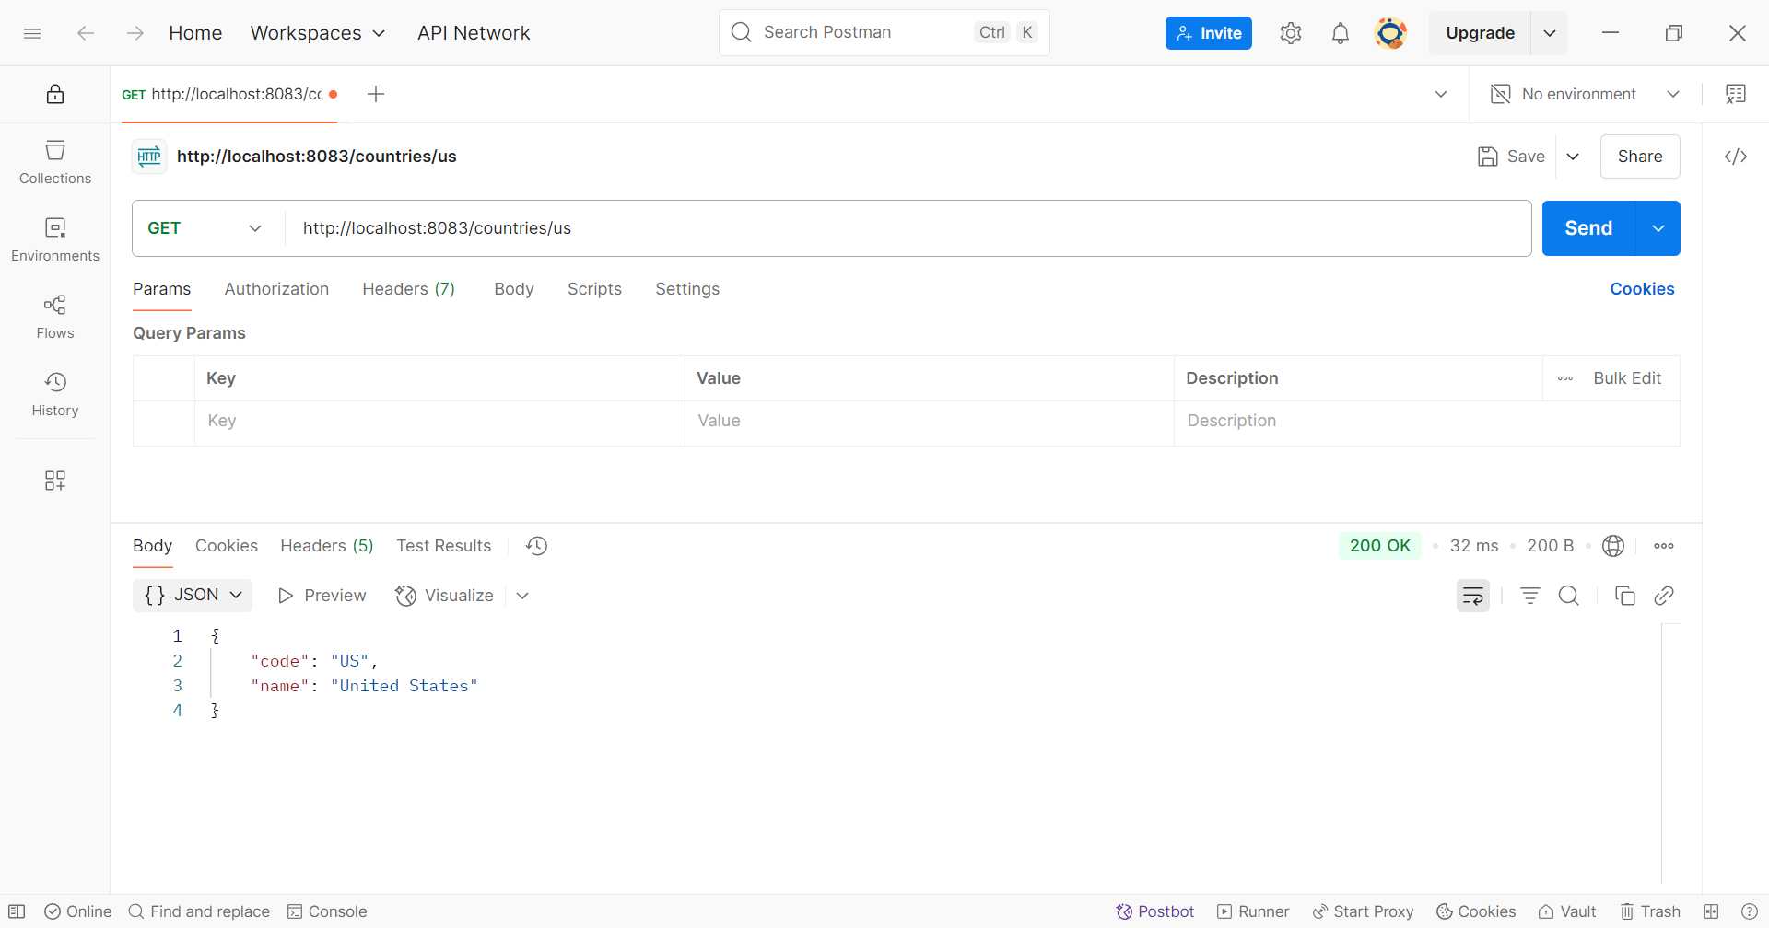

**Webbrowser at http://localhost:8083/country/us**

